TICKER TIMERS

A ticker timer will mechanically record 50 dots every second.

∴ 1 dot spacing represents 1/50th of a second = 0.02 s

Visually, the ticker tape shows whether the motion represented is constant speed or acceleration.

. . . . . . . . . . . . . . . . . . Constant speed -
dots evenly spaced.

. . . . . . . . . . . . . . . Acceleration -
dots get further apart.

Calculations

Constant speed

• Choose 1 dot as your start point.

• Count 5 dots from this point- this represents 0.1 secs.

• Measure the distance from the start to the fifth dot.

• Calculate the speed or velocity using 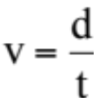.
. . . . . . . . . .
d = 11.3 cm
t = 0.1 secs

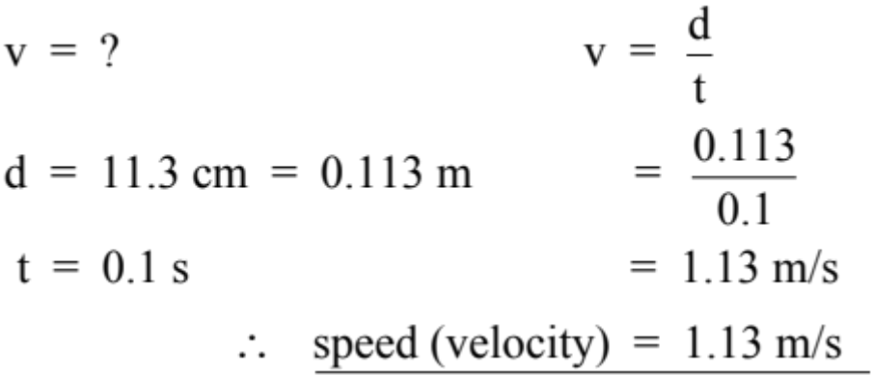

Acceleration

• Choose 5 dots near the start of the tape - this represents 4
dot spacings = 0.08 secs.

• Measure the distance for the 5 dots and calculate the
average speed as above. This is the initial velocity (u).

• Select 5 dots near the end of the tape. Measure the
distance for these and calculate the average speed - this is
the final velocity v.

• Mark the middle dot of the "u" section and middle dot of
the "v" section. Count the number of dot spacing between
them and multiply by 0.02 secs to work out the time.

• Calculate the acceleration using 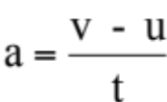.

u
v
d = 4.3 cm
t = 0.08 s
d = 15.9 cm
t = 0.08 s
. . . . . . . . . . . . . . . .

t = 11 spacings
= 11 x 0.02
= 0.22 secs

